Uher Assignment 4
Michael Uher
2026-10-31
Import Data set and enable relevant libraries
library(readxl)
library(factoextra)
## Loading required package: ggplot2
## Welcome to factoextra!
## Want to learn more? See two factoextra-related books at https://www.datanovia.com/library/principal-component-methods
Pharmaceuticals <- read_excel("C:/Users/Mike/Downloads/Pharmaceuticals.xlsx")
Separating the numerical variables and scaling them
Numeric_Vars <-c("Market_Cap", "Beta", "PE_Ratio", "ROE", "ROA", "Asset_Turnover", "Leverage", "Rev_Growth", "Net_Profit_Margin")
X_Raw <-Pharmaceuticals[, Numeric_Vars]
X_Scaled <-scale(X_Raw)
Comparing different k-values using the silhouette method and plotting the result on a graph
set.seed(123)
print(fviz_nbclust(X_Scaled, kmeans, method="silhouette", k.max=6, nstart=100))
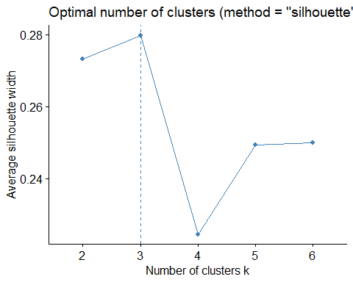
Using 3 as the optimal number of clusters k that was found using the graph above.
Final_Kmeans <-eclust(X_Scaled, "kmeans", k=3, graph=FALSE, nstart=100, seed=123)
Cluster_Id <-Final_Kmeans$cluster
Plotting the clusters using the k means method due to the clusters having non complex shapes while using the k value of 3 from the data above.
print(fviz_cluster(Final_Kmeans, data=X_Scaled, geom=c("point", "text"), stand=FALSE, main="PCA View of K-Means Clusters"))
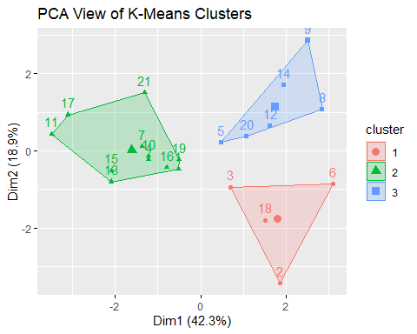
#PART B Getting the average of all of the numerical variables within each cluster to analyze how the clusters formed.
Cluster_Means <-aggregate(X_Raw, by=list(Cluster=Cluster_Id), FUN=mean)
Cluster_Means[, -1] <-round(Cluster_Means[, -1], 2)
print(Cluster_Means)
## Cluster Market_Cap Beta PE_Ratio ROE ROA Asset_Turnover Leverage
## 1 1 21.75 0.60 46.90 11.3 5.10 0.75 0.30
## 2 2 97.11 0.43 20.95 35.7 14.95 0.80 0.33
## 3 3 9.23 0.65 19.43 17.3 5.98 0.48 1.25
## Rev_Growth Net_Profit_Margin
## 1 7.01 6.65
## 2 10.16 20.17
## 3 23.49 13.52
Cluster 1 has a high PE Ratio, high Asset Turnover, low Leverage, and low Net Profit Margin. Cluster 2 has a high Market Cap, low Beta, high ROE and ROA, high Asset Turnover, and low Leverage. Cluster 3 has a low Market Cap, Low PE Ratio, low Asset_Turnover, high Leverage, and High Rev Growth.
#PART C Displaying the percentage of each of the remaining variables for each cluster to find patterns.
Recommendation_Table <-table(Cluster=Cluster_Id, Recommendation=Pharmaceuticals$Median_Recommendation)
print(round(100*prop.table(Recommendation_Table, margin=1), 1))
## Recommendation
## Cluster Hold Moderate Buy Moderate Sell Strong Buy
## 1 50.0 25.0 0.0 25.0
## 2 54.5 27.3 18.2 0.0
## 3 16.7 50.0 33.3 0.0
Location_Table <-table(Cluster=Cluster_Id, Location=Pharmaceuticals$Location)
print(round(100*prop.table(Location_Table, margin=1), 1))
## Location
## Cluster CANADA FRANCE GERMANY IRELAND SWITZERLAND UK US
## 1 25.0 0.0 25.0 0.0 0.0 25.0 25.0
## 2 0.0 0.0 0.0 0.0 9.1 18.2 72.7
## 3 0.0 16.7 0.0 16.7 0.0 0.0 66.7
Exchange_Table <-table(Cluster=Cluster_Id, Exchange=Pharmaceuticals$Exchange)
print(round(100*prop.table(Exchange_Table, margin=1), 1))
## Exchange
## Cluster AMEX NASDAQ NYSE
## 1 0.0 0.0 100.0
## 2 0.0 0.0 100.0
## 3 16.7 16.7 66.7
Cluster 1 and 2 are weighted stronger into Hold for Median Recommendation, Cluster 3 is weighted towards Moderate Buy. Cluster 1 is evenly weighted per location, cluster 2 and 3 is strongly weighted towards US. Cluster 1 and 2 are entirely on the NYSE, while cluster 3 has a third split between AMEX and NASDAQ.
#PART D Assigning names to each cluster based on the values from part B and displaying the cluster each company belongs to in a table. Cluster 1 is “High Value, Low Growth Companies”, Cluster 2 is “High Cap, High Profit Companies”, and Cluster 3 is “Small-cap, High Leverage Companies”.
Cluster_Names <-c("High Value, Low Growth Companies", "High Cap, High Profit Companies", "Small-cap, High Leverage Companies")
Cluster_Labels <-Cluster_Names[Cluster_Id]
Cluster_Results <-data.frame(Name=Pharmaceuticals$Name, Cluster=Cluster_Id, Cluster_Name=Cluster_Labels)
print(Cluster_Results)
## Name Cluster
## 1 Abbott Laboratories 2
## 2 Allergan, Inc. 1
## 3 Amersham plc 1
## 4 AstraZeneca PLC 2
## 5 Aventis 3
## 6 Bayer AG 1
## 7 Bristol-Myers Squibb Company 2
## 8 Chattem, Inc 3
## 9 Elan Corporation, plc 3
## 10 Eli Lilly and Company 2
## 11 GlaxoSmithKline plc 2
## 12 IVAX Corporation 3
## 13 Johnson & Johnson 2
## 14 Medicis Pharmaceutical Corporation 3
## 15 Merck & Co., Inc. 2
## 16 Novartis AG 2
## 17 Pfizer Inc 2
## 18 Pharmacia Corporation 1
## 19 Schering-Plough Corporation 2
## 20 Watson Pharmaceuticals, Inc. 3
## 21 Wyeth 2
## Cluster_Name
## 1 High Cap, High Profit Companies
## 2 High Value, Low Growth Companies
## 3 High Value, Low Growth Companies
## 4 High Cap, High Profit Companies
## 5 Small-cap, High Leverage Companies
## 6 High Value, Low Growth Companies
## 7 High Cap, High Profit Companies
## 8 Small-cap, High Leverage Companies
## 9 Small-cap, High Leverage Companies
## 10 High Cap, High Profit Companies
## 11 High Cap, High Profit Companies
## 12 Small-cap, High Leverage Companies
## 13 High Cap, High Profit Companies
## 14 Small-cap, High Leverage Companies
## 15 High Cap, High Profit Companies
## 16 High Cap, High Profit Companies
## 17 High Cap, High Profit Companies
## 18 High Value, Low Growth Companies
## 19 High Cap, High Profit Companies
## 20 Small-cap, High Leverage Companies
## 21 High Cap, High Profit Companies

